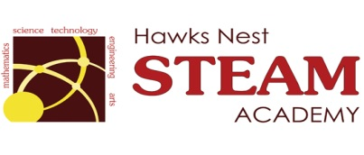 School Counseling Program Newsletter
Shandrai Silva, School Counselor | August/September 2016
Counselor Message  Welcome to the 2016-17 school year! I’m very excited about the opportunity to serve as the school counselor at Hawks Nest STEAM Academy. It’s going to be a great year.  As the school counselor, I am committed to making every students’ experience at school an enjoyable one where each student can become their very best academically, personally and socially. I look forward to meeting with every student through classroom guidance and with some students in small groups and in individual meetings.  I also look forward to the opportunity to work with parents, teachers and other school staff. As the school counselor, I have the unique experience of building relationships with and supporting everyone connected with the school family. It’s an experience I considered a privilege and an honor!  ____________________________  How to see the school counselor  Classroom guidance classes, small group counseling and individual counseling by self -referral, parent referral, teacher referral, administrator referral or counselor initiated.  Feel free to contact school counselor, Shandrai Silva @ sosilva@gaston.k12.nc.us and/or 704-866-8467. | Home of the Hawks  Happenings @ the Nest  *International Dot Day*  Join us in celebrating International Dot Day, a global celebration of creativity, courage and collaboration on Thursday, September 15th. Birthed from The Dot by Peter Reynolds, International Dot Day encourages students to trust their own abilities by being brave enough to “make their mark” and embark on a journey of creativity, confidence and self-discovery. Hawks Nest will have an opportunity to make its mark by participating in a schoolwide service project the week of September 12th. On September 15th, everyone is encouraged to wear dots on International Dot Day!  http://www.thedotclub.org/dotday/get-started  * Wear Dots on Thurs., Sept. 15th  *”Make Your Mark” service project: please donate one single toothbrush for Ronald McDonald House of Charlotte during the week of September 12th.  *Hispanic Heritage Month* | Character Education  “We’re Soaring with Good Character”  _______________________________ The character trait of the month is Responsibility. Responsibility means taking care of your duties; answering for your actions; being accountable and trustworthy. Students will learn more about responsibility through morning announcements and classroom activities.  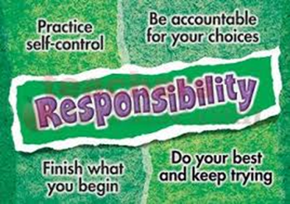  “Intelligence plus character-  that is the goal of true education.”  Dr. Martin L. King, Jr.  _____________________________________  